Day 39 Spring Batch with Scheduling
Agenda:

What is Scheduling.
Scheduling in Spring Boot.

Day 38 Spring Batch
- Real-time Data Processing (Deals with Live data)
- Batch Processing (Not immediate actions, but at a specified time interval)

Spring Boot project with Batch Processing Capability. (Read Data from CSV file and store it in the MySQL DB)
- Spring Batch
- Spring Web (Optional – Needed if it’s a micro-service)
- Eureka-Discovery Client (Optional - Needed if it’s a micro-service)
- Lombok
- DevTools
- Spring Data JPA
- MySQL
- Validation (Optional)

Job, JobParameterBuilder, JobParameters, JobLauncher
Step, JobBuilder, StepBuilder

ETL Process = Extract, Transform & Load
Extract – Extracting/getting/reading data from data source (DB, CSV/JSON file, iot devices, sensors)
Transform – Converting/processing the Data
Load – Storing data for further processing (Visualization Tools)

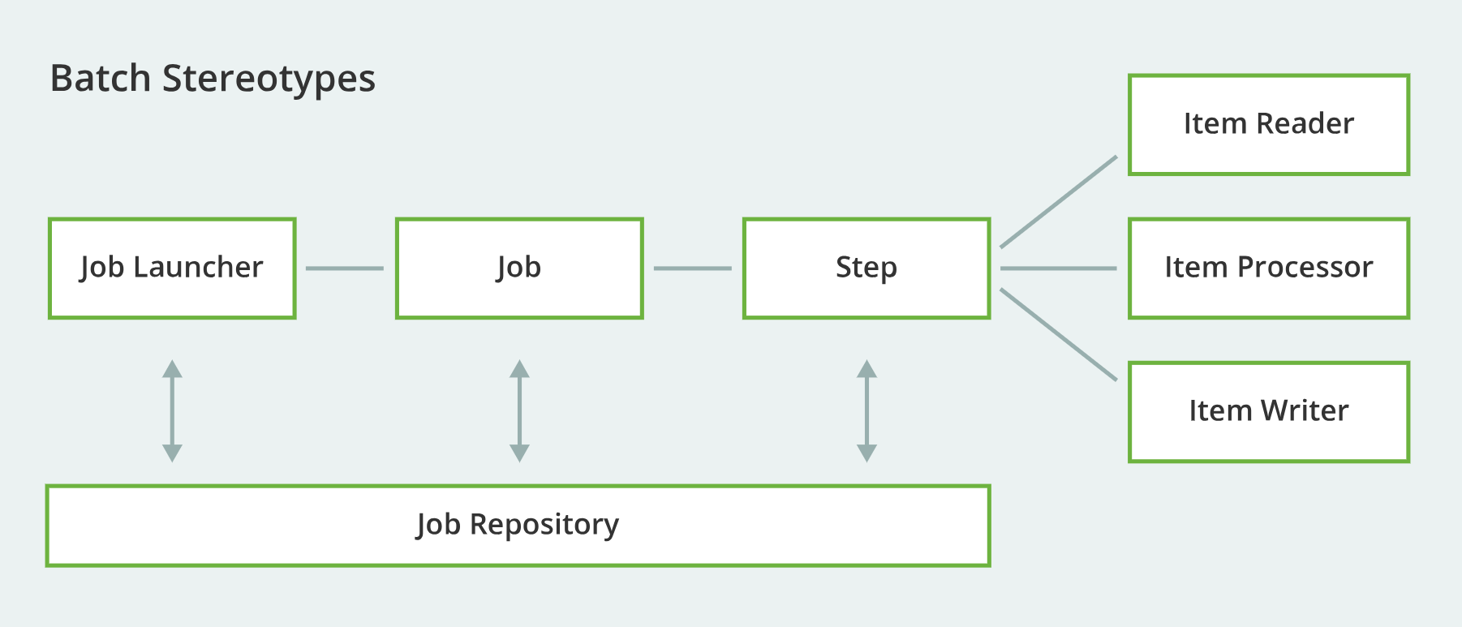

https://spring.io/batch

Scheduling – Doing some process/task/action at a specified time or at pre-defined intervals.
https://spring.io/guides/gs/scheduling-tasks
- Quartz Scheduler
- Spring Scheduler

https://github.com/spring-guides (Official Spring and Spring boot examples)

